**Set up SQL Data Sync**

|  |  |
| --- | --- |
| Agent Key | xxxxxxxxxxxxxxxxxxxxxxxxxxxxxxxxxxxxxxx |
| Meta Database Login | xxxxxxxxx |
| Password | xxxxxxxxxxxxxx |
| Local Database Name | xxxxxxxx |

**Download and Install SQL Server Express 2016 with SQL server Management Studio and Client sync agent on local machine**

**Prerequisites**

|  |  |
| --- | --- |
| **First You have to send your public IP Address to OASYS^ where you intended to install “Client Sync Agent”** E.g. : 61.245.160.180  SQL Server Express Download Page :  <https://www.hanselman.com/blog/DownloadSQLServerExpress.aspx>  Client sync agent Download Page:  <https://www.microsoft.com/en-us/download/details.aspx?id=27693>  Please read system requirements and download and install other necessary .msi files on your local machine.  Then you can install Microsoft SQL Data Sync Agent.  After installing open “Microsoft SQL Data Sync Agent 2.0” and give your local pc credential to start service.  Note: If you got error while connecting, Please refer “SQL Azure Data Sync - Troubleshooting Guide”  <https://social.technet.microsoft.com/wiki/contents/articles/2655.sql-azure-data-sync-troubleshooting-guide.aspx>  **Create SQL DATABASE to data Sync by login to the SQL Server Database Engine & Execute following query to enable SNAPSHOT_ISOLATION**   |  | | --- | | ALTER DATABASE <Local_database_Name>  SET ALLOW_SNAPSHOT_ISOLATION ON |   **If you got port related error when connecting client sync agent, please follow followings steps to open a port in the Windows firewall for TCP access**   1. On the Start menu, click Run, type WF.msc, and then click OK. 2. In the Windows Firewall with Advanced Security, in the left pane, right-click Inbound Rules, and then click New Rule in the action pane. 3. In the Rule Type dialog box, select Port, and then click Next. 4. In the Protocol and Ports dialog box, select TCP. Select Specific local ports, and then type the port number of the instance of the Database Engine, such as 1433 for the default instance. Click Next. 5. In the Action dialog box, select Allow the connection, and then click Next. 6. In the Profile dialog box, select any profiles that describe the computer connection environment when you want to connect to the Database Engine, and then click Next. 7. In the Name dialog box, type a name and description for this rule, and then click Finish. |

Most common permission error:

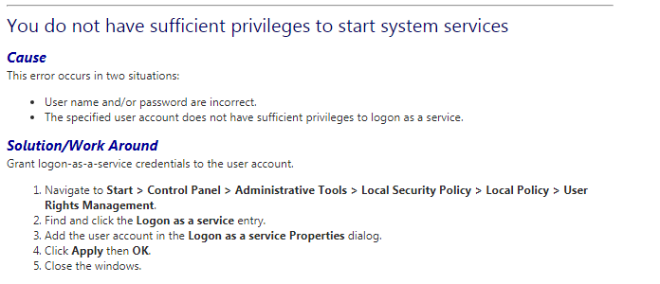

After successfully login you can see something like this.

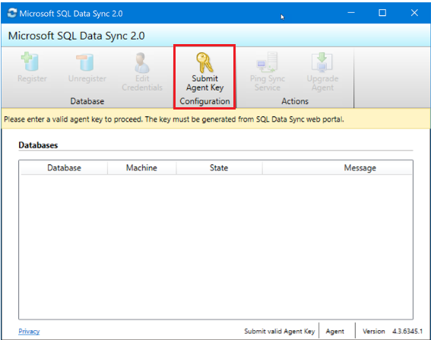

f. On the SQL Server computer, locate and run the Client Sync Agent app. (as above figure)

g. In the sync agent app, select Submit Agent Key. Then Sync Metadata Database Configuration dialog box will open.

h. In the Sync Metadata Database Configuration dialog box, paste in the agent key provided by OASYS. Also provide the credentials for the Azure SQL Database server on which the metadata database is located. (Mentioned in above table) Select OK and wait for the configuration to finish.

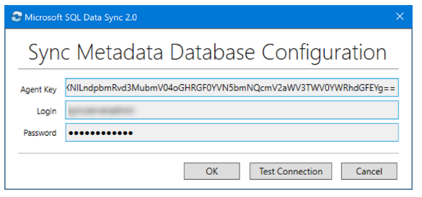

Note: If you get a firewall error at this point, you have to create a firewall rule on Azure to allow incoming traffic from the SQL Server computer. So you have to provide your Public IP Address to OASYS^.

I. In the Client Sync Agent app, click Register to register a SQL Server database with the agent. The SQL Server Configuration dialog box opens.

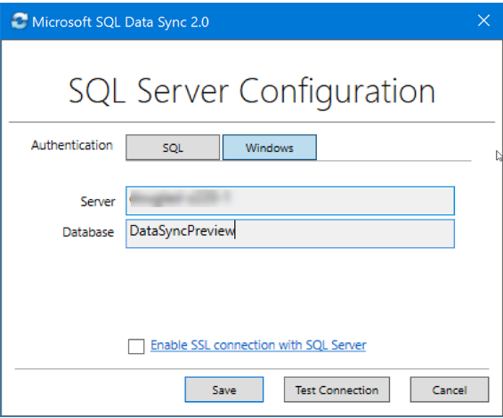

j. In the SQL Server Configuration dialog box, choose whether to connect by using SQL Server authentication or Windows authentication. If you chose SQL Server authentication, enter the existing credentials. Provide the SQL Server name and the name of the database that you want to sync.

Select Test connection to test your settings. Then select Save. The registered database appears in the list.

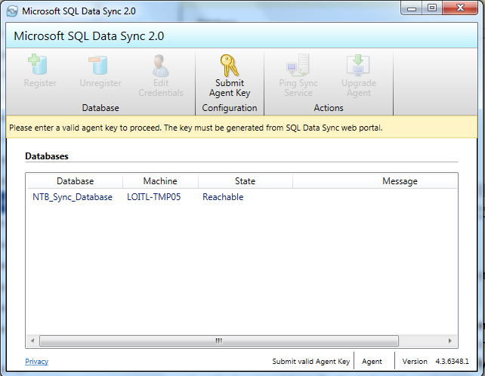

k. You can now close the Client Sync Agent app.